Nombre y apellido:
Instructor’s name:

Listening Comprehension /20

I. LISTENING COMPREHENSION: Interpretative assessment (20 points)

You are studying for your final exam and you decided to watch Univision News to practice your Spanish since you will be traveling to Spain in the summer. Read the following questions. Then, listen to the audio and answer the questions by applying listening strategies.

1. The doctor is giving advice… (2 pts)
a. to the elderly b. to be healthy c. to behave properly at the doctor’s office d. to cure a disease

2. True or false? (12 pts, 2 pts each)
According to the content of the video:
a. The doctor doesn’t like patients that ask questions T F
b. Anxiety is the main 21st century illness T F
c. Internet can offer good quality medical information T F
d. The doctor advises the audience to take between 5 and 10 different medications T F
e. Health must be conceived holistically T F
f. The Hispanic population are afraid to ask for a second opinion T F
3. What does Dr. Rivera recommend to the audience? (6 pts, 2 pts each)

a.____________________________________________________________________________________________________

b. ____________________________________________________________________________________________________

c. ____________________________________________________________________________________________________
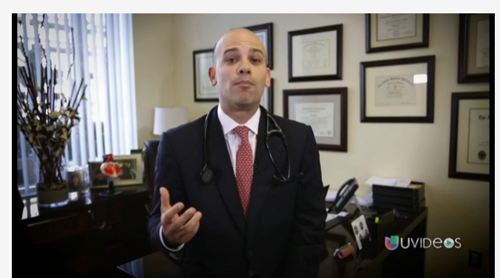
El Dr. Juan Rivera, Univisión
Nombre y apellido:
Instructor’s name:

Oral Proficiency /30

II. ORAL PROFICIENCY: Interpersonal assessment (30 points)
You and your friend meet at a café to talk about how your student life at Rutgers has been so far, especially regarding your experiences as students who live in a city (routines, illnesses, studies). You both take Spanish classes, so you decide to practice your Spanish. Create a conversation in Spanish where you include the following:

Student A
[ ] Greet your friend.
[ ] Ask him/her about how life at Rutgers has been so far
[ ] Tell your friend about your routine here at Rutgers and ask your friend about his/her routine.
[ ] Answer to your friend, tell him/her you got sick (choose a common illness) and describe its symptoms
[ ] Give two recommendations or suggestions to your friend.
[ ] Say goodbye to your friend.

Student B
[ ] Answer to your friend’s greeting.
[ ] Answer to your friend and ask him/her about his/her daily routine as a Rutgers student.
[ ] Tell your friend what your routine is like. Ask your friend if she/he got sick this semester
[ ] Give two recommendations to your friend and tell him/her that you got sick too (choose a different illness) and describe its symptoms.
[ ] Say you have to go and say goodbye

Select a role with your partner. You will have 5 minutes to prepare. You are not allowed to write a script but you can jolt down some key words.

Space for notes

II. Oral Assessment- INTERPERSONAL RUBRICS: 30 POINTS
 | 5 | 4-3 | 2 | 1
A. CONTENT/ TASK COMPLETION  Score: ______ | You have completed all the tasks assigned in a thorough manner with accurate information. | You have completed most of the tasks assigned with mostly accurate information. | You have completed some of the tasks assigned with somewhat accurate information. | You have completed very few of the tasks assigned with very little or inaccurate information.
B. COMPREHENSION  Score: ______ | You understood all of what was said to you. | You understood most of what was said to you. | You understood some of what was said to you. | You understood little of what was said to you.
C. COMPREHENSIBILITY  Score: ______ | Listener understood all of what you were trying to communicate. Errors are rare and do not impede comprehensibility | Listener understood most of what you were trying to communicate. Errors do not impact comprehensibility | Listener understood less than half of what you were trying to communicate. Errors usually do not impact comprehensibility | Listener understood little of what you were trying to communicate. Errors impact comprehensibility.
D. VOCABULARY Score: ______ | You have used a wide range of vocabulary from chapters 6 to 9 and beyond. | You have used a good range of vocabulary from chapters 6 to 9 | You have used less than the vocabulary expected from chapters 6 to 9 | You have used an inadequate amount of vocabulary, fail to incorporate new vocabulary, or included very few new words
E. ACCURACY  Score: ______ | You used language correctly almost all the time, including grammar (time references, frequency, preterit & imperfect, agreement, etc) and word order. | You have used language correctly most of the time, including grammar (time references, frequency, preterit & imperfect, agreement, etc) and word order | You have sometimes used language correctly (time references, frequency, preterit & imperfect, agreement, etc) and word order | You seldom used language correctly specially grammar (time references, frequency, preterit & imperfect, agreement, etc) and word order
F. FLUENCY  Score: ______ | You spoke clearly and without hesitation. Pronunciation and intonation seemed natural. | You hesitated a little, and had a few problems with pronunciation and intonation. | You hesitated and had some problems with pronunciation and intonation. | You hesitated frequently and struggled with pronunciation and intonation.  You read.
TOTAL: (A+B+C+D+E+F)_________ /30

Comments:
STRENGTHS | OPPORTUNITIES

